
ST ELIZABETH’S CATHOLIC PRIMARY SCHOOL
STUDENT BEHAVIOUR SUPPORT PLAN

St Elizabeth’s Mission Statement
The Mission of St Elizabeth’s Catholic Primary School is to provide a high quality, inclusive Catholic education by:
- Offering a diverse and innovative curriculum that empowers and engages learners.
- Living and celebrating the gospel amongst staff, students, and parents;
- Nurturing and valuing effective partnerships between the home, school and community.
We are committed to building a school community that is dynamic, spirit-filled, and caring.

St Elizabeth’s Vision Statement
At St Elizabeth’s Catholic Primary School, we are committed to learning and living an authentic expression of Catholic Christian community in our ever-changing world.

Our community spirit is regarded as one of our richest blessings and recognised as one of our greatest strengths. It provides the inspiration to work together to achieve our school mission.

By fostering open communication, positive encouragement, and mutual respect and cooperation, we aim to enhance and sustain quality student, staff, family, and community relationships.

In keeping with our strong coeducational focus, we strive to empower our students to reach their potential by providing a dynamic curriculum with innovative learning initiatives.

Through effective human and financial resource management, we aspire to provide and maintain a well-resourced, diverse, and contemporary curriculum within an environment that is supportive of the physical, intellectual, social, emotional, and spiritual needs of our students.

Our School Context
St Elizabeth’s, founded by the Presentation Sisters in 1958, is a well-regarded Catholic primary school grounded in a strong tradition of justice, love and community spirit. With approximately 375 students, the school continues to build on its Presentation heritage while embracing growth and renewal. The campus has undergone significant refurbishment, offering modern, well-resourced, fully air-conditioned learning spaces equipped with Phonic Ear Sound Systems to support all learners. St Elizabeth’s provides a broad range of co-curricular opportunities and benefits from an active and engaged parent community.

Consultation and Review Process
St Elizabeth’s Student Behaviour Support Plan was developed in consultation with school staff, the School Board and school community. The school Student Behaviour Support team meet twice each term to collate and review student behaviour data. This is shared with staff for regular analysis and review of effectiveness of our processes. The Student Behaviour Support Plan is reviewed every two years by staff and endorsed by the school principal and the School Board to ensure it continues to best support the students of St Elizabeth’s.

Section A: Our Student Behaviour Support Systems
1. Our Beliefs and Common Philosophy about Learning and Teaching
Our beliefs about teaching and learning socially at school, student behaviour supports, and responding to students to meet their needs, unify us and direct our actions.
In accordance with our Mission and Vision, we aspire to contribute to the development of socially aware, self-confident young people who can make responsible, ethical and informed choices when faced with the many complex challenges of the modern world. The learning and teaching experiences offered are designed to be fun, motivating, challenging and responsive to developments in information communication and learning technologies. As a community, we are committed to addressing the diverse needs of our learners, ensuring all students access the Australian Curriculum to develop the skills and knowledge appropriate to their developmental age and phase of learning.

The St Elizabeth’s school community holds the following beliefs about behaviour and learning:
- We believe that student behaviour affects and is affected by the context, ecological environment and behaviour of others.
- We believe that students need to be taught expected school behaviour through explicit teaching, modelling, scaffolding and rehearsal of skills and strategies.
- We believe that expectations about behaviour choices and their consequences, both positive and negative, need to be clear and consistent.
- We believe that a student’s capacity to make responsible behaviour choices comes about through the building of positive and open relationships between parent/s and school staff.
- We believe that positive relationships are critical for maximizing appropriate behaviour and achieving learning outcomes.
- We believe that appropriate behaviour is foundational to a positive learning environment.

2. Our Systems Approach - Positive Behaviour for Learning (PB4L)
What is Positive Behaviour for Learning?
PB4L is a framework (Diagram 1) for schools that use a system approach to positive behaviour supports for all students. The aim of implementing the framework is to achieve increased academic and social progress and achievement for all students by using evidence-based practices. One of the focus areas is explicit teaching of behaviours that assists students to access learning – academically and socially - at all stages of development throughout their education.
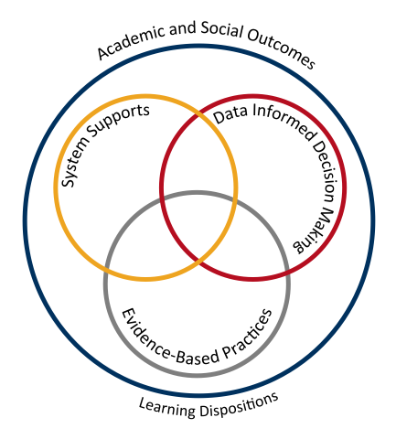
Diagram 1: Adapted from School-wide Positive Behaviour Support: implementers’ blueprint and Self-Assessment, by OSEP Centre On Positive Behavioural Interventions and Supports, 2004, Eugene OR: Lewis
Theoretical and conceptual characteristics
PB4L is the redesign of learning environments, not students. The theoretical and conceptual understandings of PB4Learning are firmly linked to Behavioural Theory and Applied Behavioural Analysis (Carr et al., 2002). This perspective emphasises that observable behaviour is an important indicator of what individuals have learned and how they operate in their environment. Environmental factors are influential in determining whether a behaviour is likely to occur, and new and alternative pro-social behaviours can be taught (Sugai & Horner, 2002; Sugai et al., 2008)

Continuum of support and key features
An important component of PB4L is the adoption of a continuum of behavioural supports (Diagram 2) that, like academic instruction, acknowledges that students will need differing levels of behavioural interventions and supports to be successful at school. Within the continuum there are three levels of support.

Tier 1 Universal Supports:
This first level focuses on universal behavioural and academic supports for all students. Here the focus is on prevention of problem behaviours, providing explicit teaching of expected behaviours and creating positive learning environments across all settings in the school. Research has shown that approximately 80-85% of students will respond to proactive universal supports, display the desired appropriate behaviours and have few behaviour problems (Horner & Sugai, 2005; Lewis, Newcomer, Trussell & Ritcher, 2006).

Tier 2 Targeted Supports:
This second level focuses on targeted supports for students who continue to display problem behaviour even with the universal supports in place. Using data analysis, students are identified early, before problem behaviours become intense or chronic, to receive targeted supports such as small group social skill instruction, academic supports, mentoring and/or self-management strategies (Sailor et al., 2013).

Tier 3 Personalised Supports:
This third level focuses on personalised supports that are intensive and individualised. These students will require highly individualised behaviour support programs based on a comprehensive behavioural assessment, which at times, will include mental health professionals and family and community services.

Diagram 2: CONTINUUM OF STUDENT SUPPORTS
Personalised or Tier 3
- Individual students
- Assessment based
- Intense, durable intervention

Targeted or Tier 2
- Students at-risk
- High efficiency
- Rapid response
Universal or Tier 1
- All students
- All settings
- Preventative, proactive

By building a connected continuum, everyone in the school is aware of how each level of support is connected to the universal systems i.e. every targeted and individualised intervention uses the universal set of behavioural expectations to increase the likelihood of maintenance and generalisation to other contexts.

3. Student Behaviour Support Leadership & Professional Learning for School/College staff

St Elizabeth’s has a Student Behaviour Support Team who meet twice each term to analyse the Engage Student Support Behaviour data and discuss practical supports implemented for students. Areas or patterns are identified for future focus, with proactive measures implemented to explicitly teach expectations in these areas.

The Student Behaviour Support Team consists of:
- Principal
- Assistant Principal Religious Education
- Primary Learning Leader
- Guidance Counsellor
- Support Teacher: Inclusive Education
- Classroom teachers, with upper and lower year levels represented

The Leadership Team support the school community in implementing the Student Behaviour Support Plan across the school and assist with managing student behaviour where necessary.
To ensure consistency across the school, staff participate in regular Professional Development. At the beginning of each school year, the processes for promoting positive behaviours, school expectations and support structures for students are revisited. Throughout the year, additional professional learning is undertaken to build teacher capacity and ensure practices remain current and effective.

Section B: Our Student Behaviour Support Practices

1. Clarity: Our Expectations
School-wide expectations encourage consistent communications and establish a common language of expectations for all staff and students and across all settings. Agreed upon student expectations promote the school’s Catholic Identity and provide consistency across the staff and school community.
Our expectations are:
- Stay Safe
- Treat Others Kindly
- Always Do My Best
- Respect the Environment
Our school behaviour matrix is a visual tool that outlines the expectations of behaviours we expect all students and staff to learn, practice and demonstrate. They allow us to teach proactively and to provide students and parents with a positive message about behaviours for learning at school.

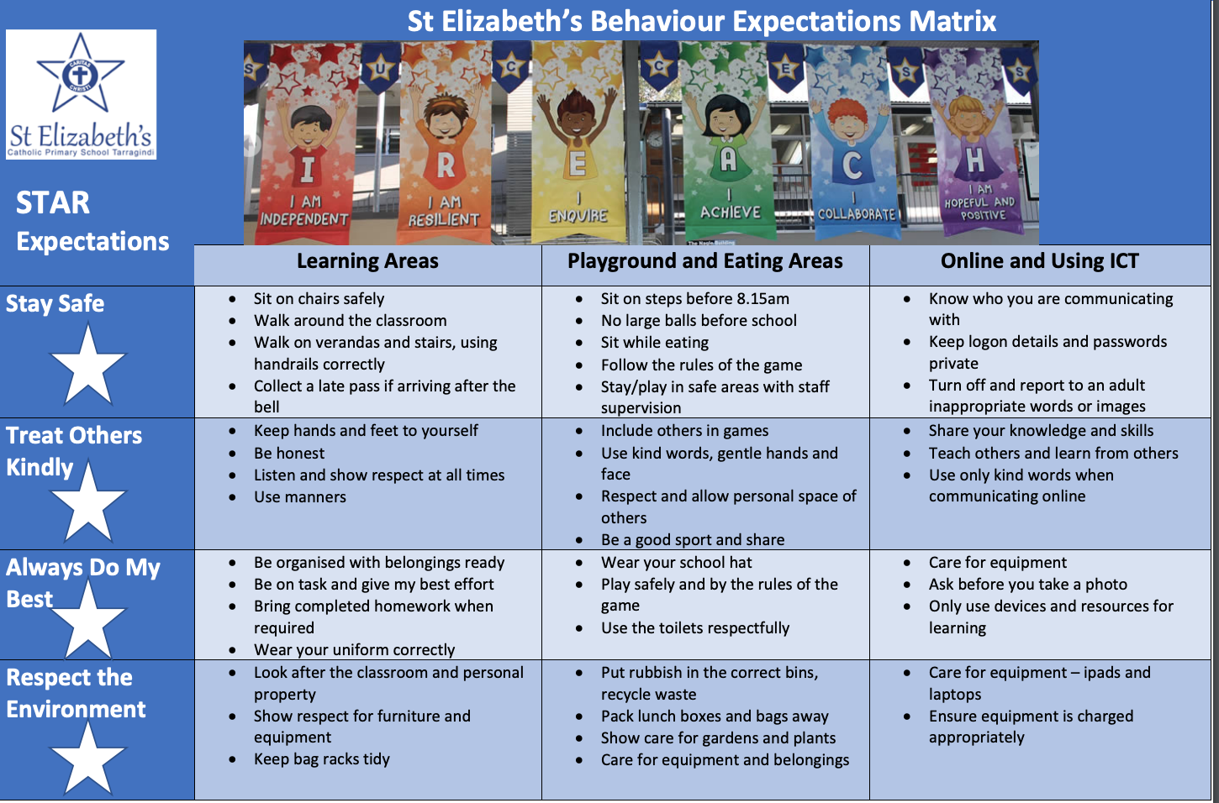

In addition to our school expectations, our affective curriculum is informed by the General Capabilities in the Australian Curriculum. The General Capabilities encompass the knowledge, skills, behaviours, and dispositions that, together with curriculum content in each learning area and the cross-curriculum priorities, will assist students to live and work successfully in the twenty-first century.
The Personal and Social Capability is one of the seven General Capabilities that outlines student developmental stages of self-awareness, self-management, social awareness and social management. The behavioural and social emotional skills in this capability are to be taught through the learning areas of the approved curriculum. www.acara.edu.au

2. Focus: Teaching Expected behaviour
Effective instruction requires more than providing the rule – it requires instruction, practice, feedback, re-teaching, and encouragement (Sprague & Golly, 2005). Instruction takes place each day, throughout the day, all year long.
In addition, direct teaching may be done using some or a combination of the following:
- Beginning of school year Student Induction – Reach for the Stars
- First Religious Education Learning Cycle in all year levels relates to moral choices
- and Christian living, making links to school expectations
- Weekly focus on one expectation, shared with staff Mondays and explicitly taught in each classroom throughout the week
- Expectation of the week reinforced at assembly
- Weekly expectation shared with parents in school newsletter, promoting partnership
- New student orientation as needed
- Student leaders support younger peers

3. Feedback: Encouraging Productive Behaviours for learning
Tier 1 Universal Supports:
Feedback should cause thinking (Dylan Wiliam, 2011). In education, we use the term “feedback” for any information given to students about their current achievements (Wiliam, 2011 p.122). Feedback to students provides them with the way to move their learning forward and make progress in their learning.
Our school encourages and motivates students, both as they are learning the expected behaviours and then to maintain those skills and dispositions as students become more fluent with their use. Specifically, our school encouragement system utilises effective, specific positive feedback, adult attention (contingent and non-contingent) and a tangible reinforcement system.
The encouragement strategies in place for school and classroom include:
School practices that encourage expected behaviours | Classroom practices that  encourage expected behaviours
STAR of the Week Award | Two students from each class receive a STAR of the Week award at the Monday fortnightly assembly. Students receiving these awards are recognised for demonstration of school expectations or learning dispositions.
Playground Champion Award | Teachers recognise the outstanding following of school expectations during lunch breaks by giving students playground champion awards. Students place the slip in the box at the student  Office (one box for P-3 and one box for Yr 4-6). At the fortnightly Monday assemblies, two names are drawn from each box, with those students selected receiving a tuckshop voucher for an ice block.
Individual Classroom Reward Systems | Age-appropriate classroom award systems are developed by teachers, in conjunction with students, such as stickers, class points and working towards class rewards.

Tier 2 Targeted Supports:
Targeted evidence-based interventions play a key role in supporting students at risk of academic and social problems and may prevent the need for more intensive interventions (Sailor et.al., 2009). These students consistently have trouble with low level but disruptive behaviours that interfere with instruction and hinder student learning. Targeted inventions should be timely and responsive and use similar strategies and social curriculum across a group of students.
Students are identified proactively, using academic, behaviour and attendance data accompanied by teacher nomination or through a screening process. Our targeted supports have systems in place to monitor student progress, make modifications, and gradually decrease support as student behaviour and engagement improves.
The evidence-based targeted supports currently available for students in the school include:

- The Behaviour Education Program (Check in- Check out) – (Crone, Horner & Hawken, 2004). This evidence-based Tier 2 support builds on the school-wide expectations by providing students with frequent feedback and reinforcement from their teacher/s, a respected facilitator, and the student’s parents for demonstrating appropriate behaviour and academic engagement. The goal is to move the student to self-management.

- Social Skills Groups. This type of intervention involves directly teaching social skills to enhance a student’s ability to interact with peers and adults. Whilst social skill instruction may be part of the work done in universal supports this type of targeted support occurs in smaller groups with students who require additional practice and feedback on their behaviour. A teacher or guidance counsellor facilitates this type of group.

Tier 3 Personalised Supports:
Successful outcomes for students whose behaviour has not responded to Universal or Targeted supports are dependent on our ability to intervene as early as possible with appropriate evidence–based interventions. A function-based approach is an essential feature of PB4L.
Personalised supports currently on offer at the school include:
- Functional Behavioural Assessment with associated plan
- Individual Behaviour Support Plan
- Pro-active, Collaborative Problem-Solving process (Dr Ross Greene)
- Guidance Counsellor support services
- Student Support Team case management - planning and implementation of individualised support plans and monitoring data
- Partnerships with outside support agencies and specialists

4. Feedforward: Responding to Unproductive Behaviours
Even with our positive approach to teaching and supporting expected behaviours for learning, unproductive student behaviour will still occur. For some students, they do not know how to perform the expected behaviour, or don’t know it well enough to routinely use it at the appropriate times. For some students, the maladaptive behaviours they are using appear to meet their needs. When responding to unproductive behaviours, all staff take a positive, supportive approach that builds, maintains, and sustains relationships with students.
To feedforward when responding to unproductive student behaviours, we have a system in place that enables staff to respond to minor unproductive behaviours efficiently and effectively, to chronic persistent minor behaviours and to major unproductive behaviours that hinder learning. In this continuum, thinking begins with clarity between minor behaviours (that can and should be managed by teachers, within the context of the classroom and non-classroom settings) and major behaviours (that are best managed in a more private setting with the class teacher and leadership in partnership). The definitions of teacher managed behaviours (Minor) and teacher plus leadership managed behaviours (Major) have been included in Appendix A.
Although the teacher is the key problem solver when responding to minor behaviours, they collaborate, and share creative strategies, with colleagues. Teachers respond to minor behaviours using best practices that include reminders of expectations, re-directing to learning and re-teaching behaviours. Appendix A includes a summary of practices that may be utilised.
The positive, support strategies currently in place for responding to unproductive behaviours at our school can be classified under the three evidence-based approaches recommended in BCE SBS policy and procedures, and include:

De-escalation | Problem-solving | Restorative
- Supervised calm time in a safe space in the classroom  - Supervised calm time in a safe space outside of the classroom  - Set limits  - Individual crisis support and management plan | - Teacher – student conversation  - Work it out together plan – teacher and student  - Teacher – student – parent meeting  - Teacher – student – leadership conversation | - Student apology  - Student contributes back to the class or school community  - Restorative conversation  - Restorative conference

In addition, de-escalation crisis prevention and support strategies may include the
responses outlined in Appendix B.

5. BCE Formal Sanctions

In the event of ongoing challenging behaviour, where the above strategies have been ineffective, or in response to a serious incident, formal sanctions endorsed by Brisbane Catholic Education may be applied. These include:

Detention process

Detention is time a student spends in an alternate school area due to
unacceptable behaviour. Detention will be supervised by a member of the
Leadership or Support Team and be appropriate for the behaviour, taking into
account the age, development and specific needs of the student. Detentions
are recorded in the school’s Engage system for data collection.

Suspension process

Suspensions are imposed as a disciplinary action and can be imposed on an
internal or external basis. A suspension restricts a student’s engagement with
the school community. The length of a suspension will be based on the
unacceptable behaviour/s exhibited.

When a suspension is imposed, the Principal will notify parents immediately by
telephone and follow up with an official Suspension letter. The parents/carers
and the student will be given the opportunity to respond. It is expected the
school and parents/carers work collaboratively to assist the suspended student
re-enter the school community as quickly as possible.

Suspensions are recorded in the school’s Engage system for data collection.

Exclusion

Exclusion is the full-time withdrawal of a student from an enrolled school on
the authority of the Executive Director of Brisbane Catholic Education.

In extreme circumstances, the Principal, in consultation with the Senior Leader:
Progress and Performance, makes a submission to the Executor Director
recommending exclusion of a student from a Brisbane Catholic school.
Exclusion from one school does not prohibit enrolment at another Brisbane
Catholic school, unless explicitly prohibited by the Executive Director.

Parents who consider any decision unreasonable may submit a written appeal outlining their concerns and the grounds for the appeal. Appeals can be made to:
- Appeals for short suspensions should be made to the school Principal
- Appeals for suspensions of longer periods should be made to the Senior Leader: Progress and Performance.
- Parents may appeal exclusions to the Executive Director.
Appeals Process

Sanction | Appeal process
Suspension 1-5 day | Appeal made to the school principal
Suspension 6+ days | Appeal made to the Senior Leader School Progress and Performance by emailing SchoolProPer@bne.catholic.edu.au.
Outcome of Appeal | The appeal reviewer (Principal or Senior Leader – School Progress and Performance) must:  (a) make the review decision within 5 business days after the application is made; and  (b) as soon as practicable after the decision is made give the person written notice of the decision.
Exclusion | An appeal against an exclusion must be submitted in writing to the Compliance and Performance Executive within 10 school days after receiving notification of the exclusion.

6. Bullying and Cyberbullying – information, prevention, and school/college responses
The purpose of this section of our School Student Behaviour Support Plan is to describe our approach to positive, proactive practices in support of student behaviour and wellbeing in relation to the prevention, intervention and responses to student bullying and harassment (inclusive of victimisation of students with disability and their associates).
Definition
The national definition of bullying and harassment for Australian schools says:
Bullying is an ongoing and deliberate misuse of power in relationships through repeated verbal, physical and/or social behaviour that intends to cause physical, social and/or psychological harm. It can involve an individual or a group misusing their power, or perceived power, over one or more persons who feel unable to stop it from happening.
Bullying can happen in person or online, via various digital platforms and devices and it can be obvious (overt) or hidden (covert). Bullying behaviour is repeated, or has the potential to be repeated, over time (for example, through sharing of digital records).
Bullying of any form or for any reason can have immediate, medium and long-term effects on those involved, including bystanders. Single incidents and conflict or fights between equals, whether in person or online, are not defined as bullying. (Ref: Bullying No Way).
Our whole-school approach to preventing and responding to student bullying and harassment
Our school uses the PB4L framework and the Australian Education Authorities resource Bullying NoWay! to assist our students, staff and school community to understand, teach, prevent and respond to bullying and harassment.
- Understanding Bullying and Harassment
Staff engage in professional learning to support a positive school culture and
promote a safe environment for all.
This is achieved through:
- Participation in mandatory Student Protection and Bullying and Harassment training, undertaken annually
- Ongoing professional development about bullying/cyber-bullying awareness, prevention and response strategies
- Teaching about Bullying and Harassment
Students are taught to respect the dignity of all and foster positive, healthy
relationships.

Teaching about bullying and harassment occurs through:
- Specific links in Health and Religion curriculum learning areas
- Direct teaching leading up to National Anti-Bullying Day
- Superflex program
- UR Strong program

- Responding to Bullying and Harassment
At St Elizabeth’s, a proactive and preventive approach is undertaken. However,
it is the responsibility of all staff, parents and students to report any incident
considered bullying and harassment.

Parents and students should, in the first instance, discuss issues with their class
teacher. Teachers will
• collect information
• assess immediate safety concerns
• provide possible strategies
• discuss a course of action
• set a date to review
• notify relevant staff – Leadership Team, Guidance Counsellor

If parents or students are still concerned after this, an appointment is to be
made with a member of the leadership team.
All staff must take all reports of bullying and harassment seriously and respond with a school team process.
- Listen carefully and calmly, and document what the student tells you. (Take the time to clarify with the student who has reported the incident that you have all the facts, including if there are immediate safety risks and let the student know how you will address these).
- Collect information, document and evaluate, including examples from the student/s, staff and bystanders involved.
- Contact parent/guardian to inform them of the incident, give details of the school’s immediate response, and how the incident will be followed-up. Contact appropriate school personnel (Principal and school leadership). Always maintain confidentiality and privacy.
- Determine if this is an incident of bullying or harassment. If the incident does not meet the criteria for bullying or harassment, it can be recorded as a pastoral note in the Engage Student Support System.
- Record the incident either as Minor-Teasing or Major-Bullying/Harassment and complete the bullying record in the Engage Student Support System in a timely manner.
- Respond to incident, following the school’s student behaviour support plan. Where possible, schools should work towards a positive outcome and relationships are restored. Formal sanctions could be part of this response.
- Plan the response with the student/s and their families to provide support, teaching and strategies.
- Follow-up and gather any additional information, including data analysis on Engage Student Support System. Set a date for follow up review and monitoring.
- Preventing Bullying and Harassment
At St Elizabeth’s, preventing bullying and harassment is the responsibility of all
in our community – staff, parents and students. We aim to build mutually
respectful relationships that align with authentic Christian living, where all have
a sense of belonging.

We achieve this by:

- Embedding the Positive Behaviour 4 Learning Framework. This includes
the explicit teaching of expected behaviours, promoting weekly focus at
assemblies, weekly staff news and in the school newsletter
- Establishing learning environments that are inclusive, respectful of
difference and promote co-operative relationships
- Building play environments that promote active participation and friendly
interaction
- Ongoing professional learning for staff on promoting social and
emotional well-being, bullying awareness and prevention strategies
- Resources are regularly emailed and shared with staff, including links
and Be You information
- Ongoing awareness and education for the school community through newsletter inserts and parent information nights to assist building a positive school culture

Key contacts for students and parents to report bullying
Principal: Mrs Jenna Webb
Assistant Principal: Mrs Letitia Lee
Primary Learning Leader: Mrs Marita Fox
Guidance Counsellor: Mrs Deb White & Mrs Paula Carroll

Cyberbullying
Cyberbullying is treated at St Elizabeth’s with the same level of seriousness as direct bullying.
It is important for students, parents and staff to know that BCE Principals have the authority to take disciplinary action to address student behaviours that occur outside of school hours or school grounds. This includes cyberbullying. In addition, parents and students who have concerns about cyberbullying incidents occurring outside of school hours should immediately seek assistance through the Office of the e-Safety Commissioner or the Queensland Police Service.
In responding to an incident of cyber bullying and harassment, we will:

- Listen carefully and calmly, and document details of incident
- Assess situation for immediate safety concerns
- Record evidence and collect any additional information, including device where school issued
- If not already, advise Principal or member of the Leadership Team
- Contact parents
- Inform parents and students school’s course of action
- Record incident in Engage Student Support System
- Monitor and follow up with students at regular intervals moving forward
Resources
The following resources assist in building awareness, preventing and responding to
incidents at St Elizabeth’s:
- The Australian Curriculum, specifically Personal and Social Capabilities and
- Health and Physical Education
- Bullying NoWay Website
- Be You Program
- Office of the eSafety Commissioner

Section C: Our Student Behaviour Support Data
1. Data Informed Decision Making
The BCE Engage Student Support System is the database all BCE schools are required to use to collect behavioural data for analysis and decision-making. The Engage Student Support System has capacity to record minor and major behavioural incidents so that schools can make data informed decisions about student supports. It also has capacity for schools to record, store and analyse Tier 2 Targeted and Tier 3 Personalised supports, information, and data.
It is mandatory for all BCE schools to record major incidents of bullying, weapons and drugs incidents and complete the accompanying record documentation in the system as comprehensively as possible. Suspension records are also mandatory to complete in the database.

At St Elizabeth’s, behavioural data is used with other data sources to make data
informed decisions to enable appropriate support for students.
The information is used during:

- Behaviour Team meetings to identify whole school focus rules and provide
feedback at staff meetings
- Fortnightly Student Support meetings to assist personalised and targeted
responses

References
Carr, E. G., Dunlap, G., Horner, R. H., Koegel, R. L., Turnbull, A. P., & Sailor, W. (2002). Positive Behavior Support: Evolution of an applied science. Journal of Positive Behavior Interventions, 4, 4-16.
Christenson, S., Stout, K. & Pohl, A. (2012). Check and Connect- Implementing with Fidelity. University of Minnesota.
Crone, D. A., Horner, R. H., & Hawken, L. S. (2004). Responding to problem Behavior in schools. New York: Guilford Press.
Greene, R.W. (2014). Lost at school: Why our kids with behavioral challenges are falling through the cracks and how we can help them. New York: Scribner.
Horner, R. H. & Sugai, G. (2005) School-wide positive behavior support: An alternative approach to discipline in schools. In L. Bambara & L. Kern (Eds.), Positive behavior support (pp359-390). New York: Guilford.
Lewis, T. J., & Newcomer, L., Trussell, R., & Richter, M. (2006). School-wide positive behaviour support: Building systems to develop and maintain appropriate social behaviour. In C.S. Everston & C.M Weinstein (Eds.), Handbook of Classroom management: Research, practice and contemporary issues (pp833-854). New York: Lawrence Erlbaum.
Newton, S. J., Horner, R. H., Algozzine, R. F., Todd, A. W., & Algozzine, K. M. (2009). Using a problem-solving model to enhance data-based decision making in schools. In W. Sailor, G. Dunlap, G. Sugai & R. Horner (Eds.) Handbook of positive behavior support (pp. 551-580). New York, NY: Springer
Sailor, W., Dunlap, G., Sugai, G., & Horner, R., Eds. (2009). Handbook for positive behavior support. New York: Springer Science and Business Media.
Sprague, J. & Golly, A. (2005). Best behavior: Building positive behavior support in schools. Boston, MA: Sopris West Educational Services.
Sugai, G., & Horner, R.H. (2002). The evolution of discipline practices: School-wide positive behaviour supports. Child and Family Behaviour Therapy, 24. 23-50.
Witt, J. C., Daly, E. J., & Noell, G. (2000). Functional Behaviour Assessment: A Step by Step Guide to Solving Academic and Behaviour Problems. New York: Sophis West.
Relevant Brisbane Catholic Education Policies
- BCE Student Protection Processes
- Procedure: Alcohol and other drug-related issues
- Procedure: Weapons in Schools
- Code of Conduct
- Student Attendance policy
- Student Diversity and Inclusion policy
- Student with Disability policy
- Student Behaviour Support policy
- Student Behaviour Support procedure
- Student, Parent and Guardian Complaints Management policy
- Student Wellbeing policy.
Appendix A - Behaviour Definitions
Minor Behaviours
 | Descriptor | Definition | Example
1 | Inappropriate verbal language | Student engages in low intensity instance of inappropriate language | Calling someone an “idiot”, swearing if they kick their toe
2 | Physical contact | Student engages in non-serious, but inappropriate contact | Pushing in the tuckshop line, horseplay
3 | Disrespect/non-compliance | Student engages in brief or low intensity failure to respond to reasonable adult requests | Saying “No”, “Not going to do it”, “I don’t want to do that”
4 | Disruption | Student engages in low intensity, but inappropriate disruption | Calling out, talking to a peers in class
5 | Uniform violation – Minor | Students wears clothing that is near but not within the school’s dress code | Wrong socks, wrong shorts for sport
6 | Technology Violation - Minor | Student engages in non-serious but inappropriate (as defined by the school) use of mobile phone, mp3 player, camera and/or computer | Making a mobile phone call in breach of school’s policy
7 | Property misuse | Student engages in low intensity misuse of property | Using equipment contrary to its design or purpose
8 | Late | Students arrive late to class | Tardy or late to class not late to school as this is often beyond the control of a primary school student
9 | Out of Bounds | Student is in an area within the school grounds that has been designated “off limits” at that particular time
10 | Lying/Cheating | Student engages in “White Lies” | “I came first”, “It wasn’t me!”, “I didn’t do it”
11 | Teasing | Isolated inappropriate comments (ongoing teasing would fit under Bullying) | Laughing at someone’s misfortune
12 | Sexual Behaviour | Sexual behaviours that are normal, age-appropriate, spontaneous, curious, mutual, light-hearted and easily diverted experimentation. | Green light behaviours
13 | Incomplete tasks | Student has failed to complete a set piece of work in a clearly specified time frame | Has difficulty starting learning task, continuing on task or completing learning tasks
Major Behaviours
 | Descriptor |  | Definition | Example
1 | Verbal Aggression |  | Language (both overt and covert) directed at others in a demeaning or aggressive manner intended to harm, distress coerce or cause fear | Swearing, aggressive stance, language directed to hurt or show disrespect, intimidating body language, intimidating tone of voice
2 | Physical Aggression |  | Actions (both overt and covert) involving serious physical contact where injury might occur that is directed towards another and intended to harm, distress coerce or cause fear | Hitting, punching, hitting with an object, kicking, pulling hair, scratching
3 | Bullying/Harassment |  | Bullying/Harassment are behaviours that target an individual or group due to a particular characteristic; and that offends, humiliates, intimidates or creates a hostile environment. It may be a single or ongoing pattern of behaviour.  Bullying involves the misuse of power by an individual or group towards one or more persons | Bullying may include: Physical: hitting, kicking, any form of violence; Verbal: name calling, sarcasm, spreading rumours, persistent teasing, intimidation; Emotional: excluding, tormenting, ridiculing, humiliating, intimidating; Racial: taunts, graffiti, gestures, intimidation; Sexual: unwanted physical contact, abusive comments, intimidation. Cyber bullying may include a combination of behaviours such as pranking calling, sending insulting text messages, publishing someone's private information, creating hate sites or implementing social exclusion campaigns in social networking sites. Can also include 'flaming' and online hate sites/bash boards.
4 | Defiance/non-compliance |  | Failure or refusal to comply or obey directions, a resistance to authority | Refusing a reasonable request of a teacher or supervisor, talking back in an angry and/or rude manner to staff, ignoring/walking away from staff, running away
5 | Disruption |  | Persistent behaviour causing an interruption in a class or an activity | Sustained loud talking, yelling or screaming; repetitive noise with materials; and/or sustained out-of-seat behaviour
6 | Dress Code Violation |  | Student wears clothing that does not fit within the dress code of the school | “Gang” undershirts, offensive T-shirts, steel capped shoes.
7 | Vandalism/Property Damage |  | Student participates in an activity that results in substantial destruction or disfigurement of property | Throwing a computer, graffiti of school buildings, arson
8 | Truancy |  | Regular or persistent unexplained absences from school or from a class, where the reason given is unsatisfactory | Students leaves class/school without permission or stays out of class/school without permission
9 | Theft |  | Dishonestly appropriating another person’s property with the intent to destroy or permanently deprive the person of it | Stealing school or personal property
10 |  | Forgery/Plagiarism | Student has signed a person’s name without that person’s permission (forgery). Plagiarism is submitting someone else’s work as your own. It occurs when a writer deliberately uses someone else’s language, ideas, or other original (not common knowledge) material without acknowledging its original source. | Using someone else’s ideas or writing without acknowledging the source material. Signing another person’s name such e.g. a parent or teacher on a document.
11 |  | Technology Violation | Student engages in inappropriate (as defined by school) use of school technology including cell phone, music/video players, camera, and/or computer | Accessing inappropriate websites, using someone else’s log in details, inappropriate additions to Facebook (written and images)
12 |  | Vaping/Cigarettes | Student is in possession of or is using a vape/cigarette | Vapes, cigarettes
13 |  | Drug-use or Possession | Student is in possession of or is using illegal drugs/substances or imitations or is using prescription drugs contrary to their doctor’s directions | Cannabis, alcohol, prescription or other chemical drugs, drug related equipment
14 |  | Weapons  Use or possession | A weapon is any object, device or instrument designed as a weapon that through its use is capable of causing bodily harm | Knife, toy gun, gun
15 |  | Combustibles  Use or possession | Student is in possession of substances/objects readily capable of causing bodily harm and/or property damage | Being in possession of or using matches, lighters, firecrackers, gasoline, lighter fluid
16 |  | Bomb Threat/False Alarm | Student delivers a false message of possible explosive materials being on-school site, near school site, and/or pending explosion with the intent to disrupt school | The intent is one of a “prank” to disrupt the school day and/or Emergency Services. May include pulling a fire alarm or written or verbal bomb threat.
17 |  | Concerning  Sexual Behaviour | Orange behaviours - Sexual behaviours that are outside normal behaviour in terms of persistence, frequency or inequality in age, power or ability  Red behaviours - Sexual behaviours that are problematic or harmful, forceful, secretive, compulsive, coercive or degrading | Explicit sexual talk or play, persistent nudity, repeated exposing of private parts to others and/or in public  Forcing others to be involved in sexual activity, using mobile phone and the internet which includes sexual images.
18 |  | eCrimes/Cyber exploitation | Illegal actions that are carried out through the use of a mobile device or technology to take advantage of another | Stealing someone’s identity and impersonating them online, sending sexually explicit images
19 |  | Academic Disengagement | Student does not complete and/or submit summative assessment pieces or avoids exams | Avoiding group assignment work, minimal drafting of assessment or has difficulty engaging with learning over a period of time

Appendix B – Positive Behaviour 4 Learning Support Processes
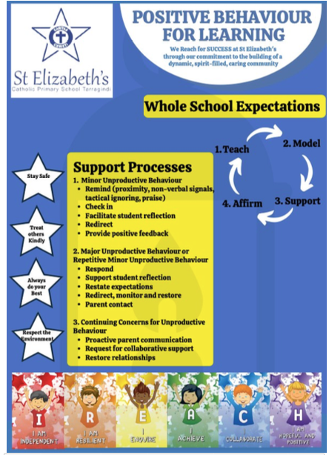

/Approver: | Principal | Issue date: | 28/07/2025 | Next review date: | 28/07/2028

